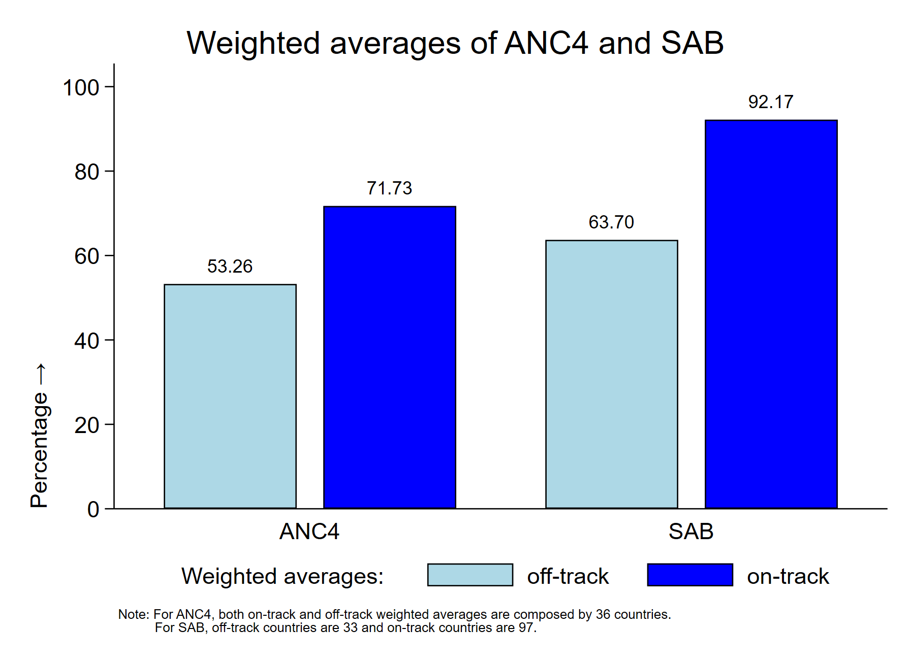
TASK 1: Interpretation of the results

The graph above presents the weighted average of antenatal care with 4 or more visits (ANC4) and skilled birth attendants (SAB) across countries in the UNICEF Global Data Repository, categorized into on-track and off-track groups. As expected, on-track countries exhibit significantly higher percentages for both indicators compared to off-track countries. The rate of SAB in on-track countries is nearly 100%, indicating that skilled health professionals assist almost all births in these 97 countries. The gap between on-track and off-track countries for this indicator is substantial, exceeding 30%. This underscores the need for the 33 off-track countries to strengthen their health systems to achieve SDG 3 targets. Similarly, ANC4 coverage shows a notable difference, with on-track countries achieving a weighted average of 71.73%. However, the gap between the two groups is slightly lower, at just under 20%.

